- Create an S3 bucket and upload some objects to S3.
Step 1: Login to AWS and select S3create bucketprovide detailscreate bucket.
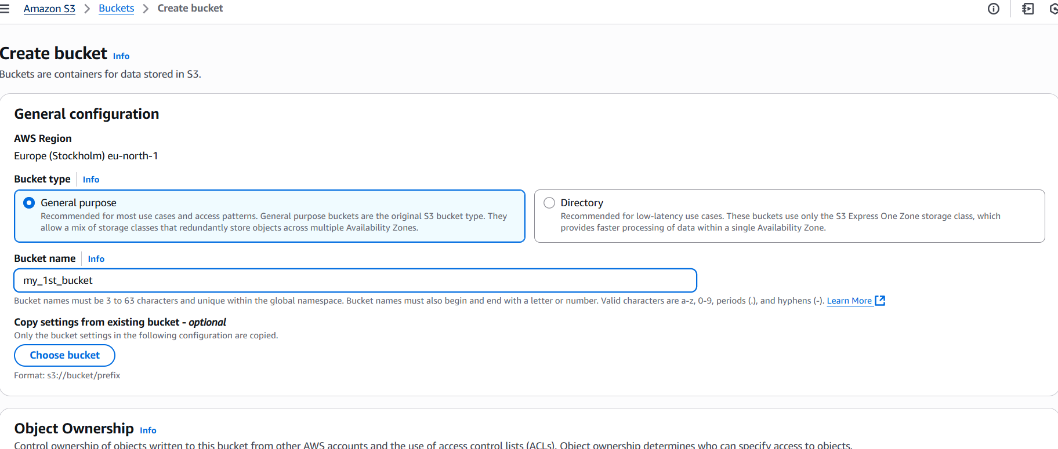
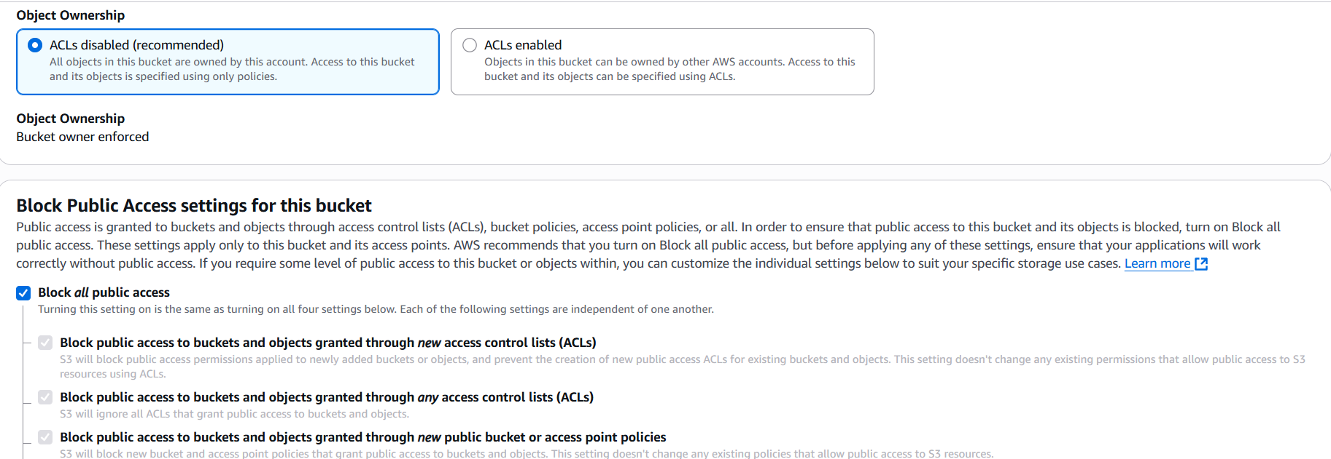
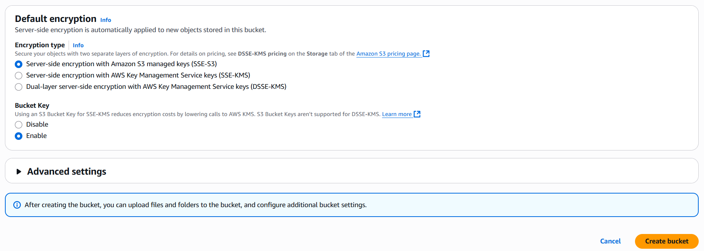

Step 2: Select your bucketuploadAdd filesupload.
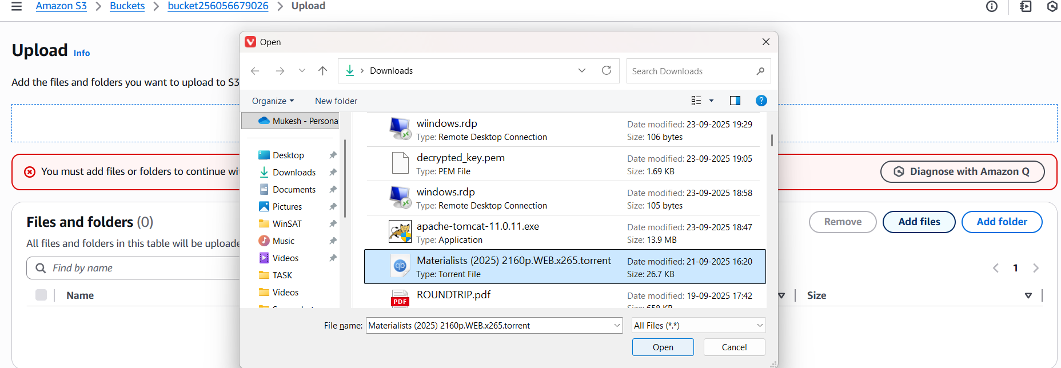
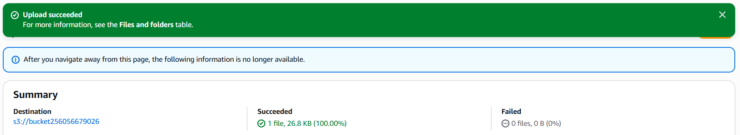
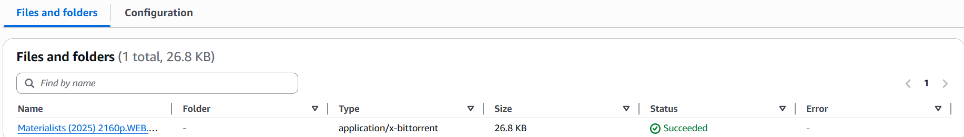

- Deploy a static website in the S3 bucket.
Step 1: Select bucketpropertiesEdit Static website hosting.
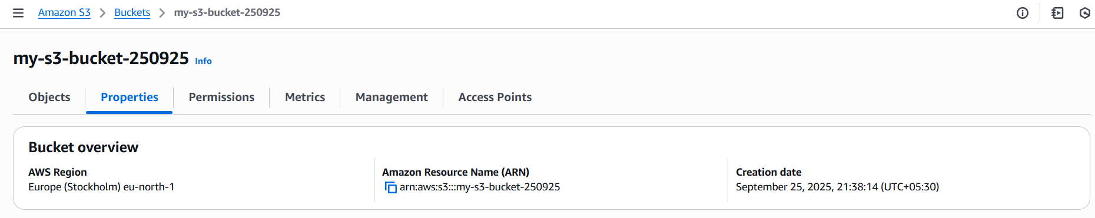
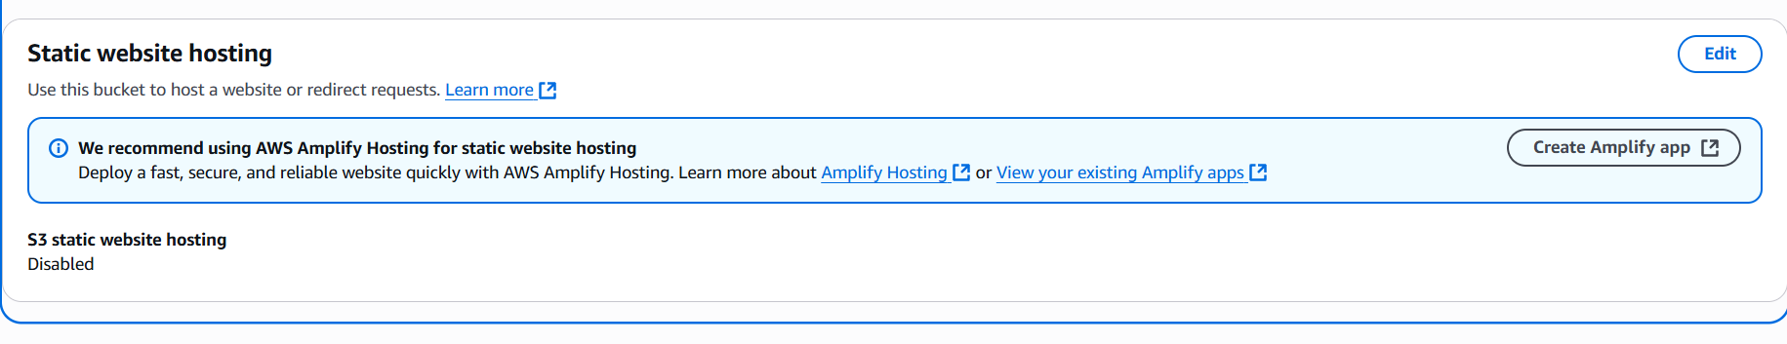

Step 2: select Enabletype index.html error.htmlSave changes.
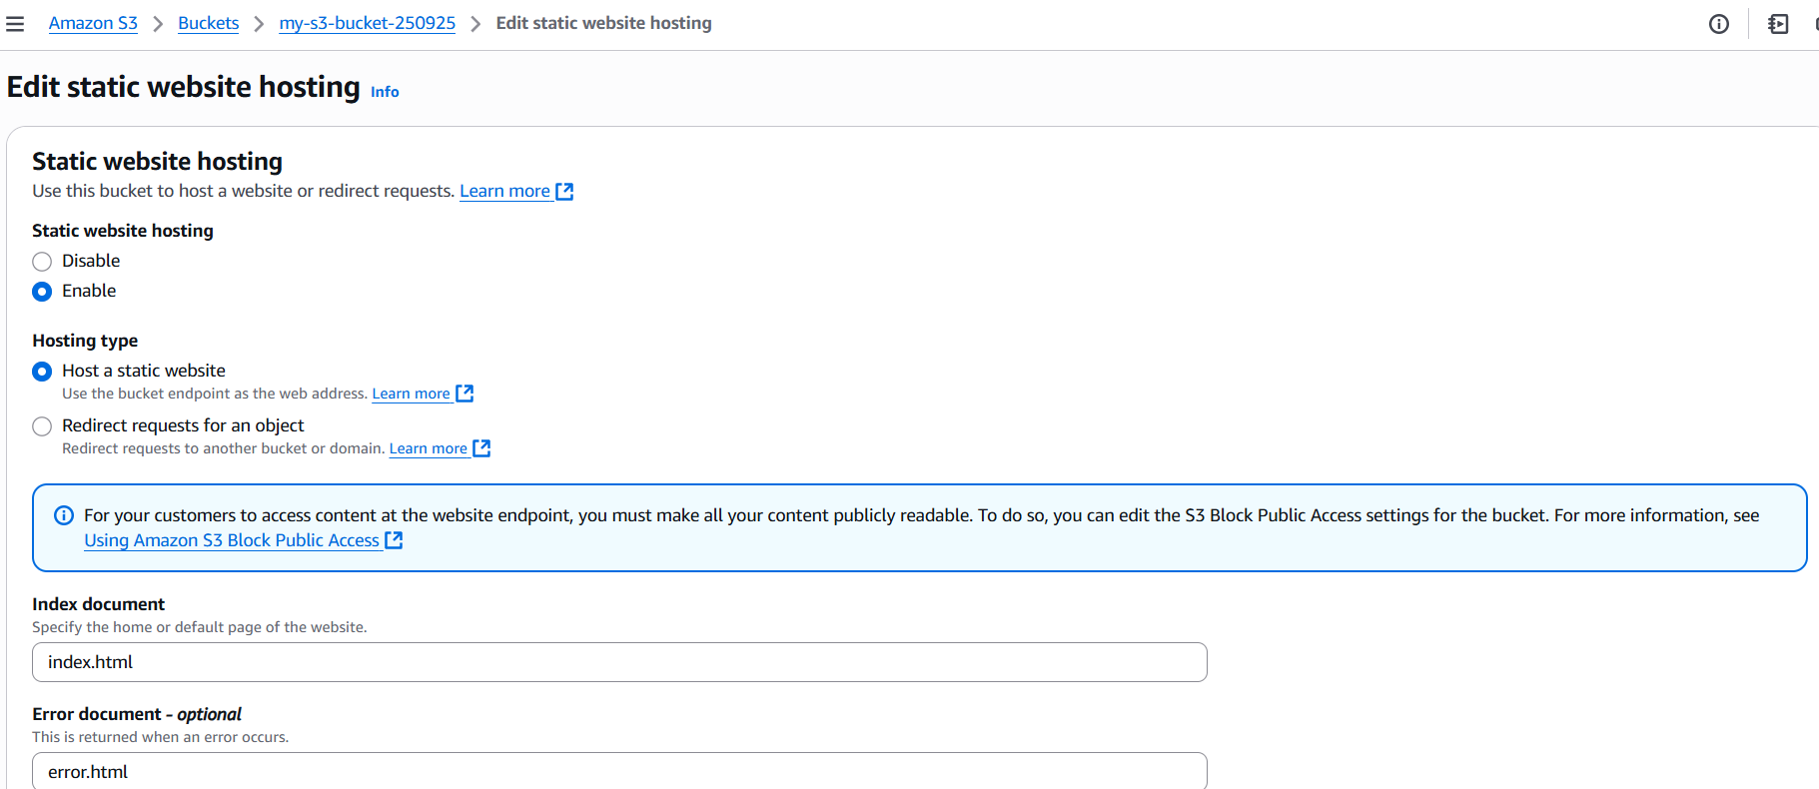
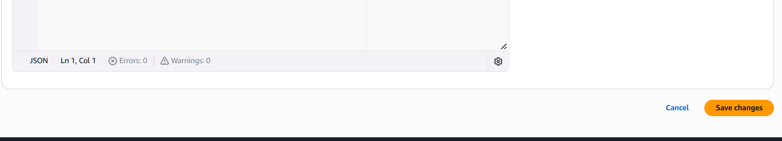
Step 3: Run object URL in browser.
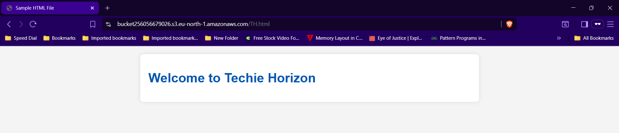

- Enable cross-region replication on S3 buckets.
Step 1: Create 2 buckets of different regions.
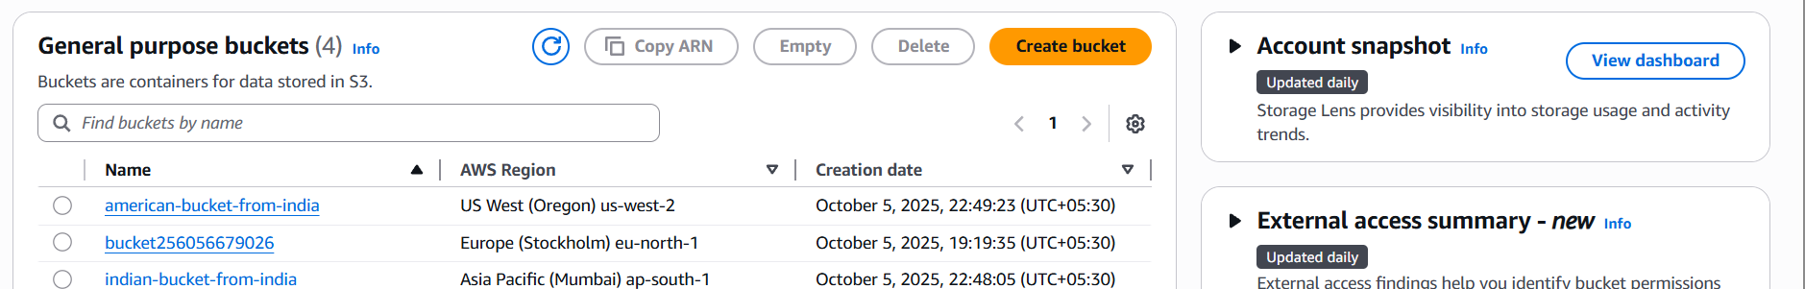

Step 2: Select a Bucketmanagementcreate replicate ruleEnter detailssavesubmit.
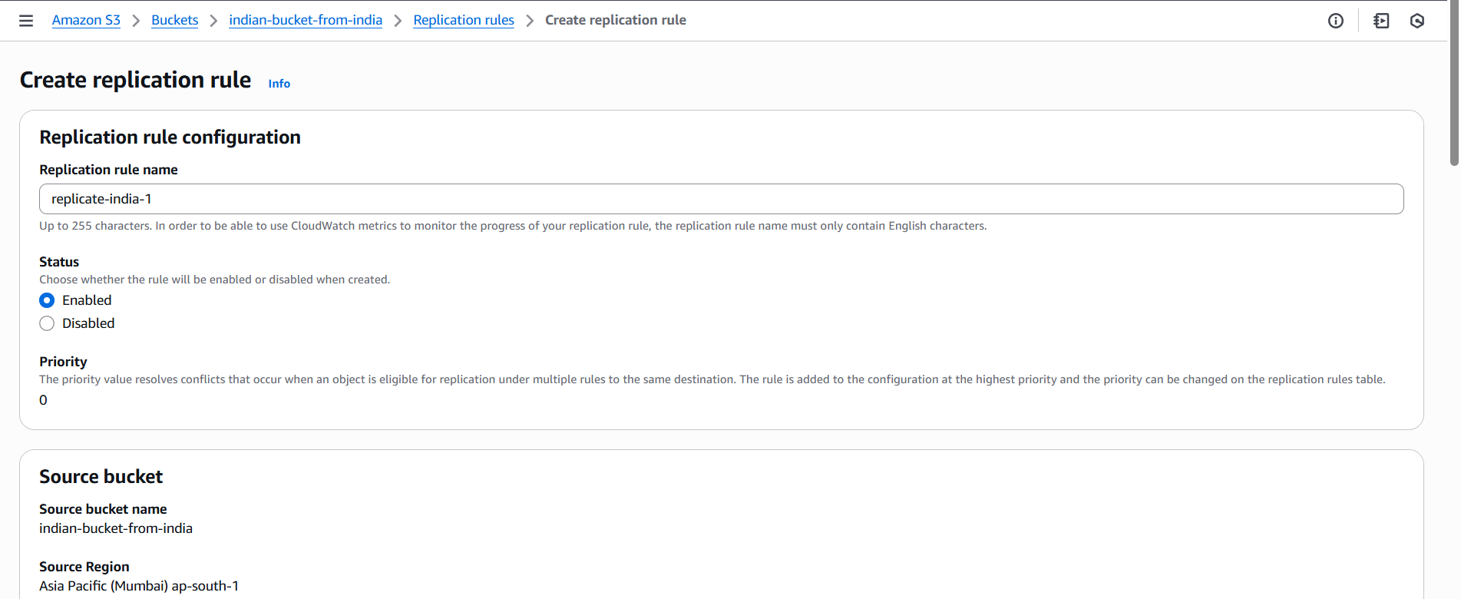
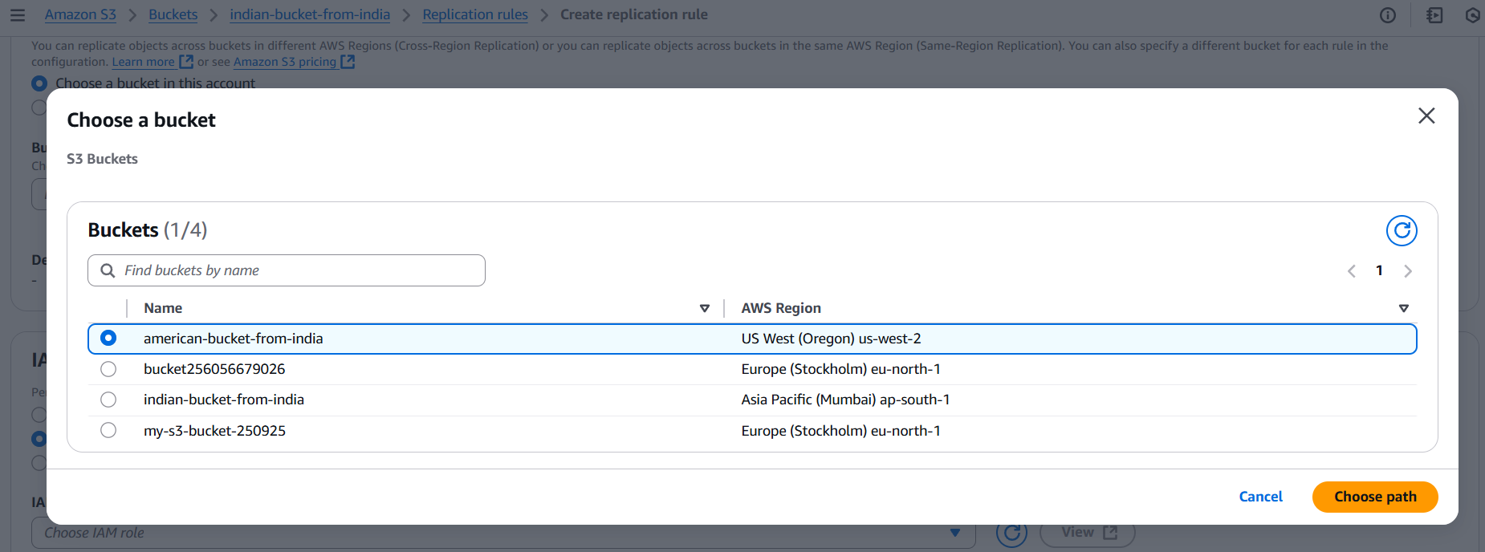
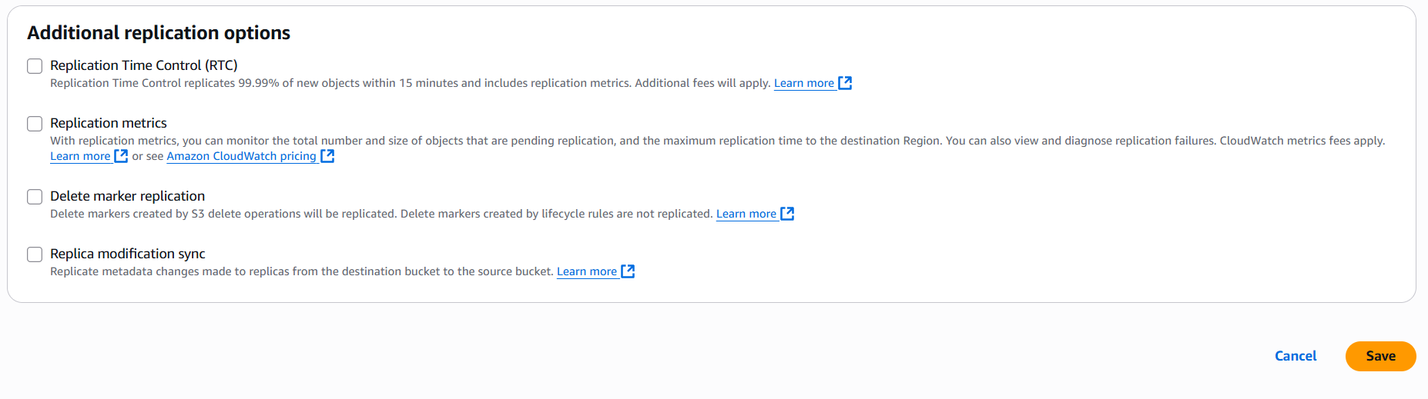
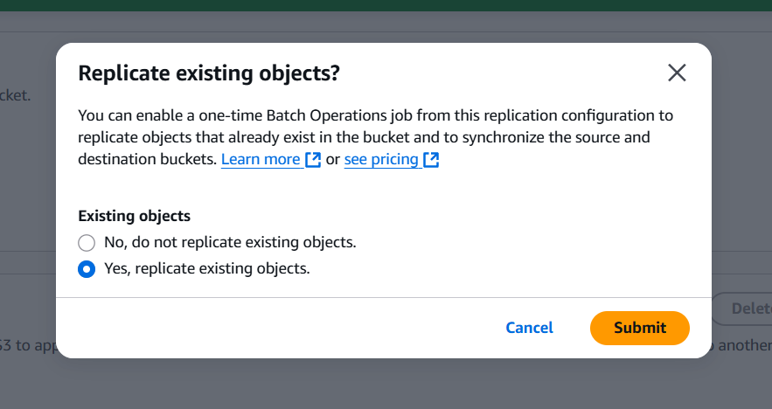
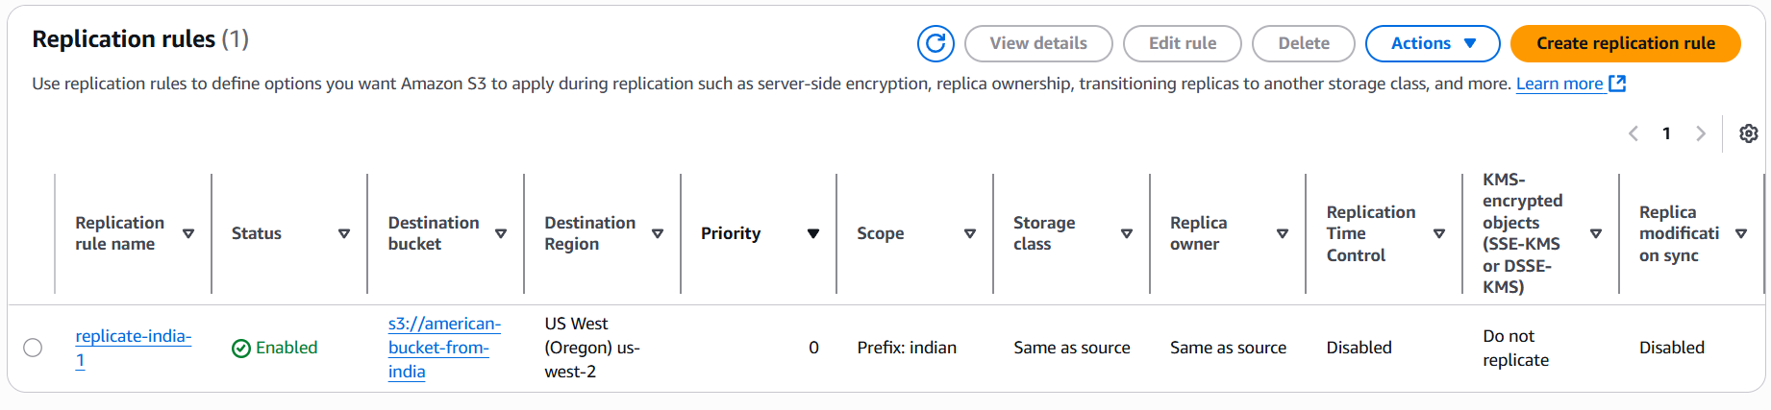

- Configure a bucket policy so only the Admin user can see the objects of the S3 bucket.
Step 1: Select a BucketPropertiescopy ARN id.
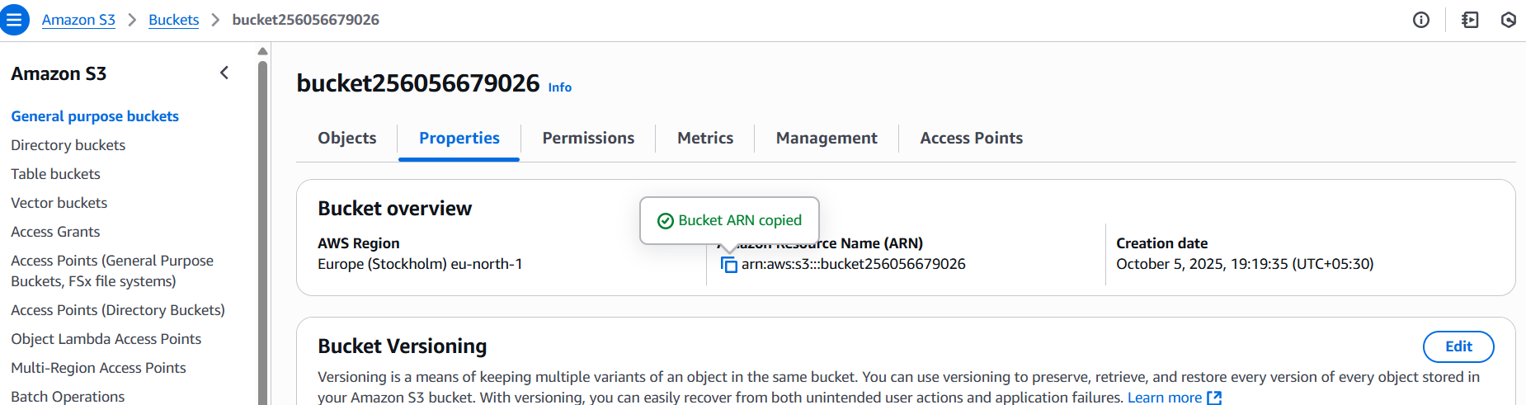
Step 2: In browser search AWS policy generator and provide detailsselect generate policy copy policy.
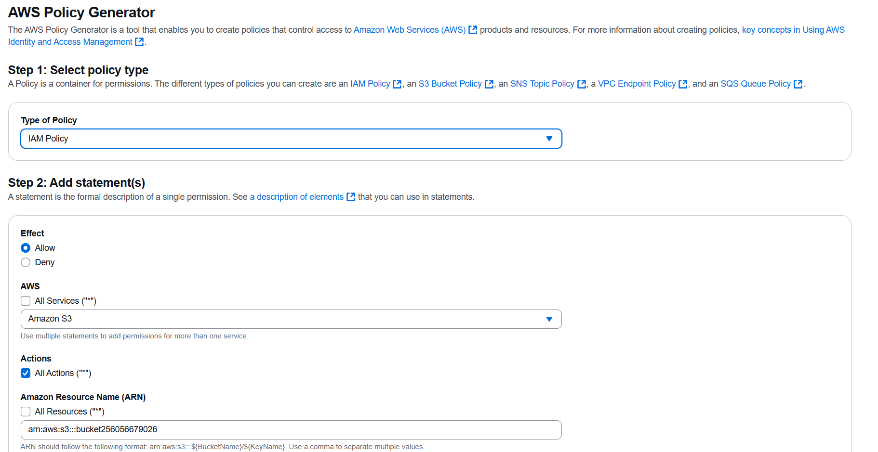
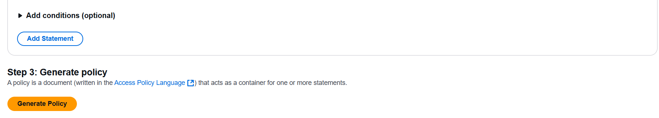

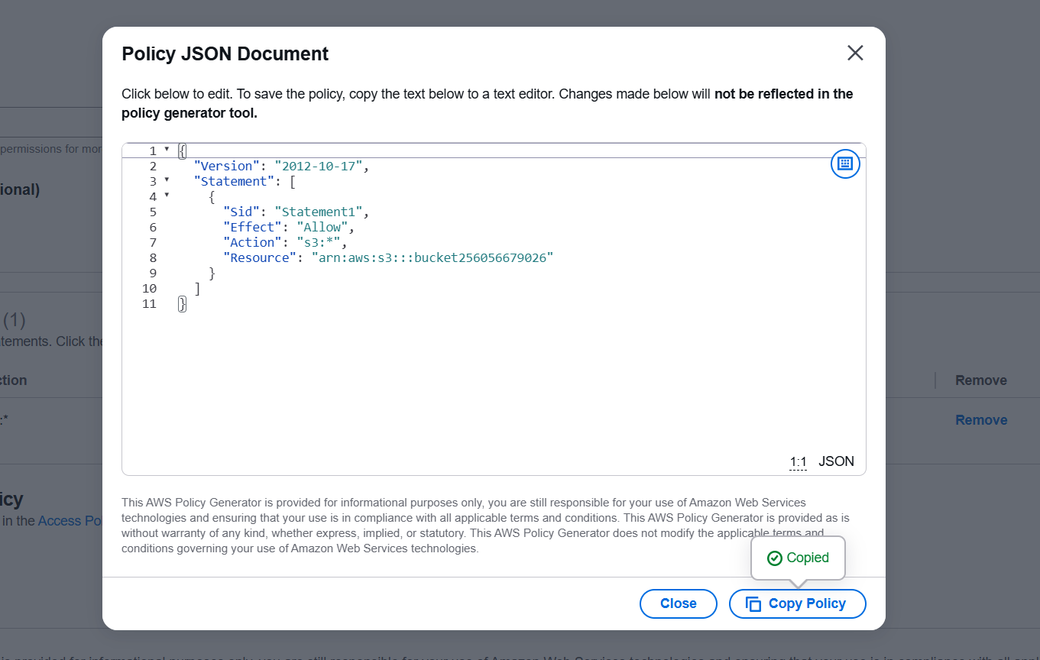
Step 3: Goto IAMpoliciescreate policyjsonreplace the policyNextcreate policy.
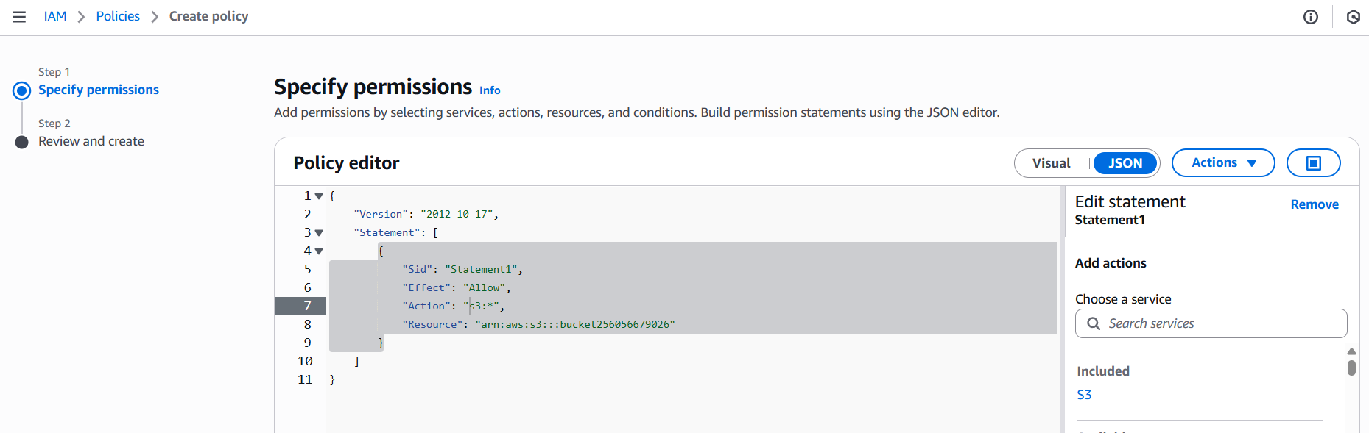
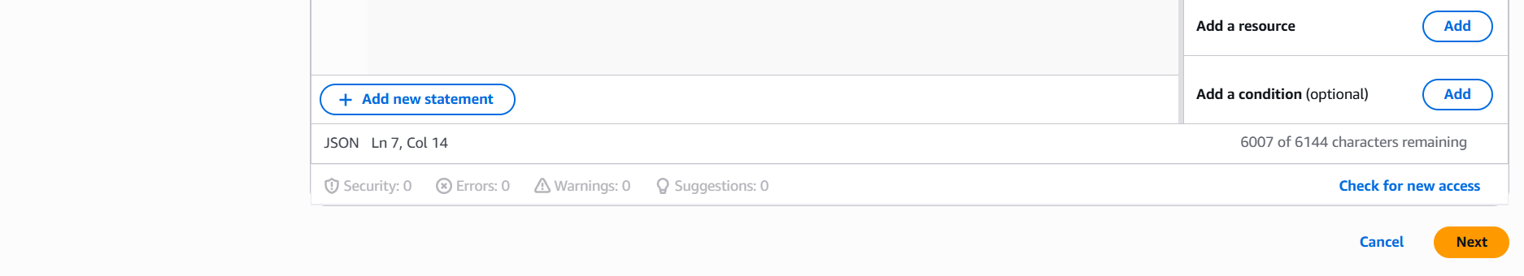
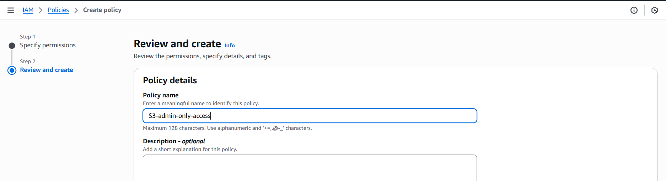

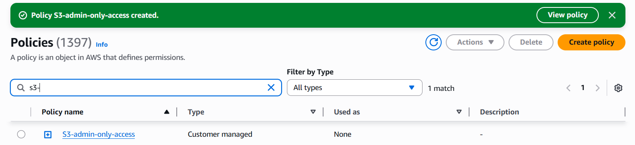
Step 4: Goto IAMusercreate userAttach policies directlyCreate user.
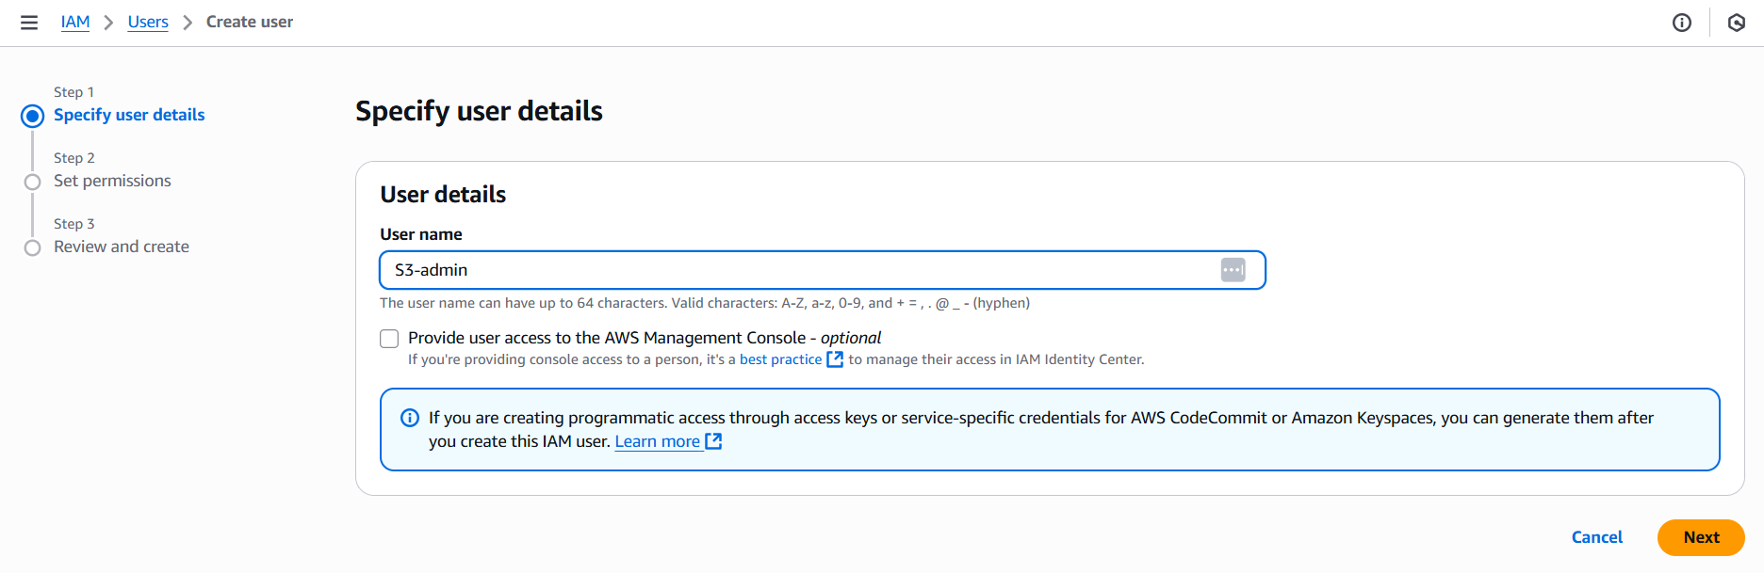
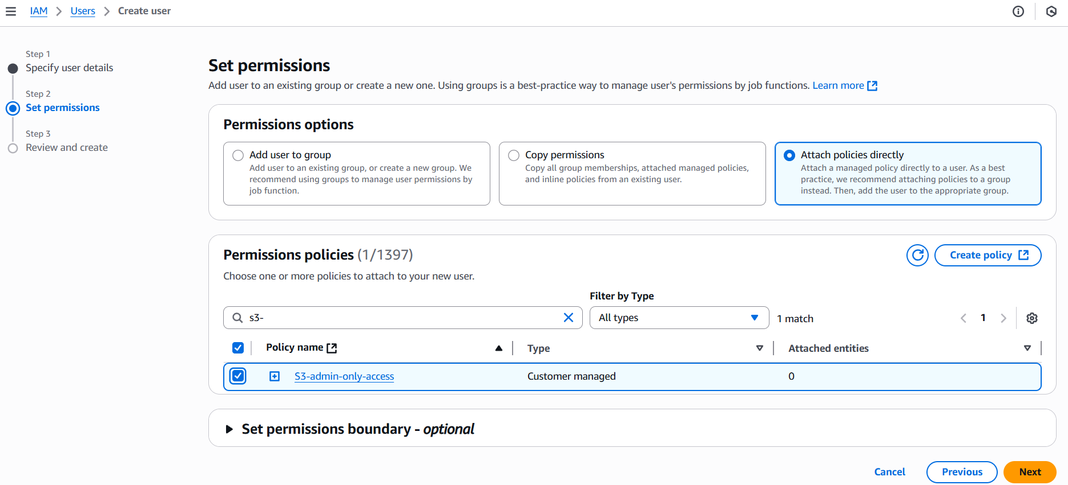
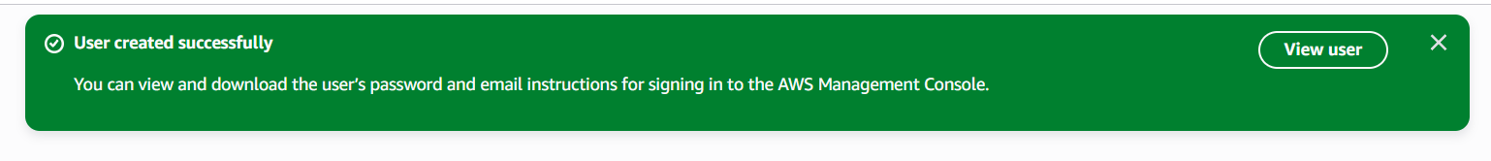

- Set up lifecycle policies to automatically transition or delete objects based on specific criteria.
Step 1:Goto S3select bucketmanagementcreate lifecycle rule.
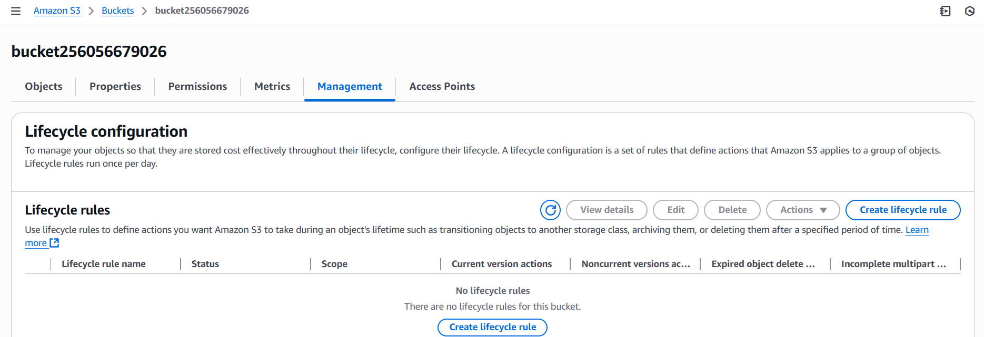
Step 2:
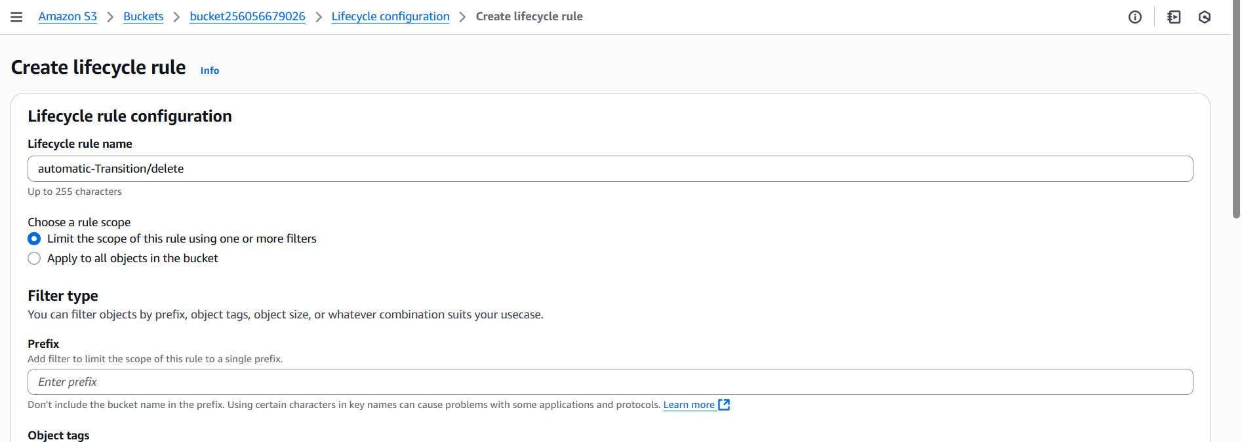
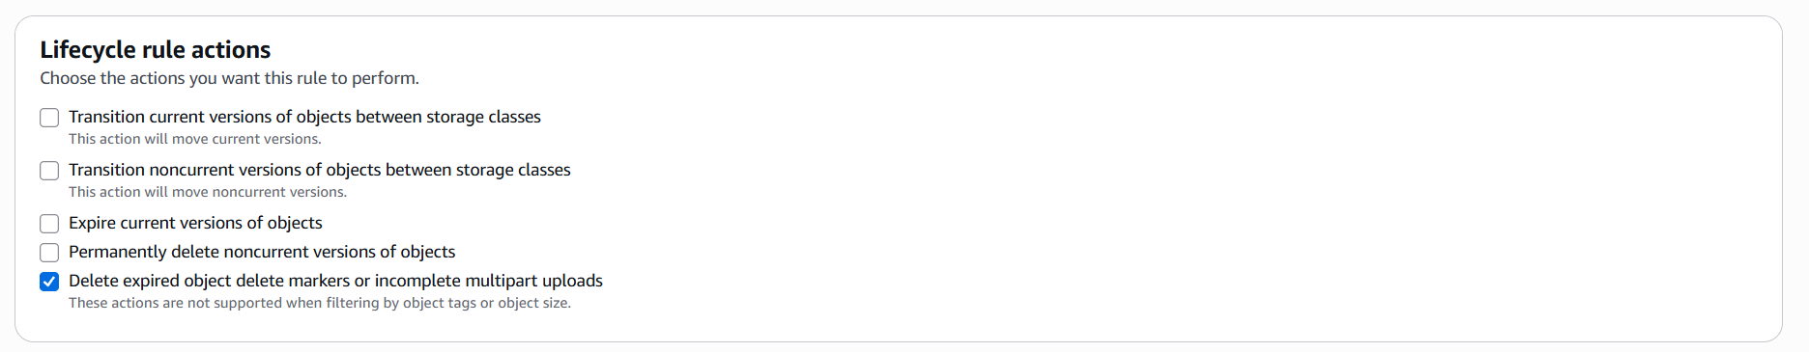
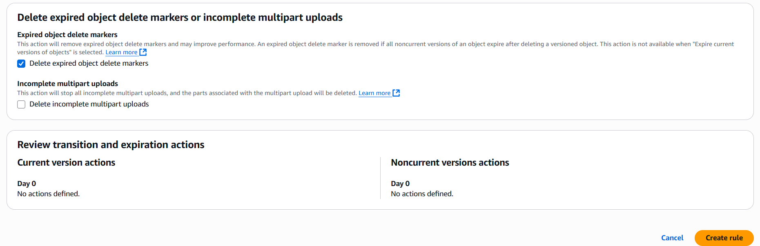
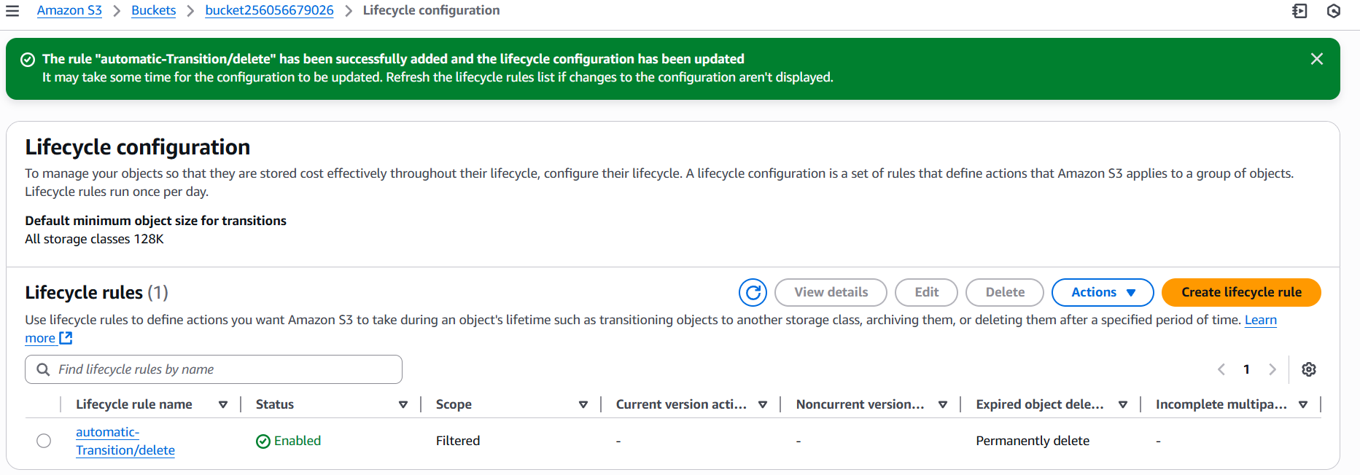

- Push some objects to S3 using the AWS CLI.
Step 1: Configure EC2 instance with Access key and secret key using aws configure command.
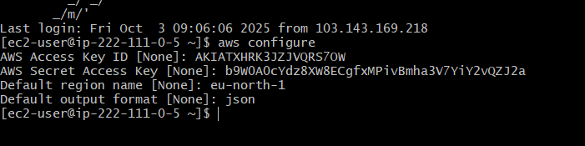
Step 2: use command aws s3 cp path_to_local_file.txt s3://bucket-name/object_name.
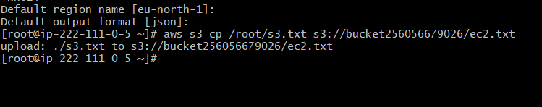
Step 3: Check it in S3 bucket.
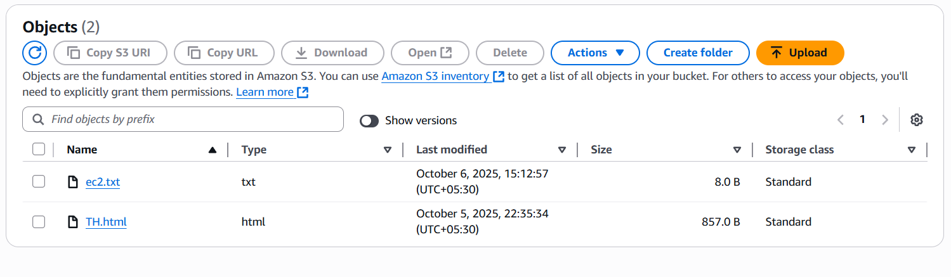

- Write a Bash script to create an S3 bucket.
Step 1: Check whether AWS CLI is installed or not by using aws --version if not installed, install it using sudo yum -y install aws-cli.
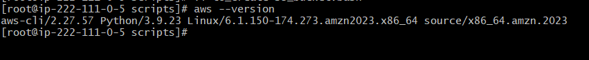
Step 2: create a bash file file.bash, give executable permission and enter the script to create S3 bucket.
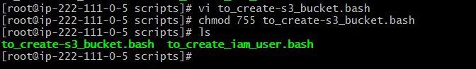
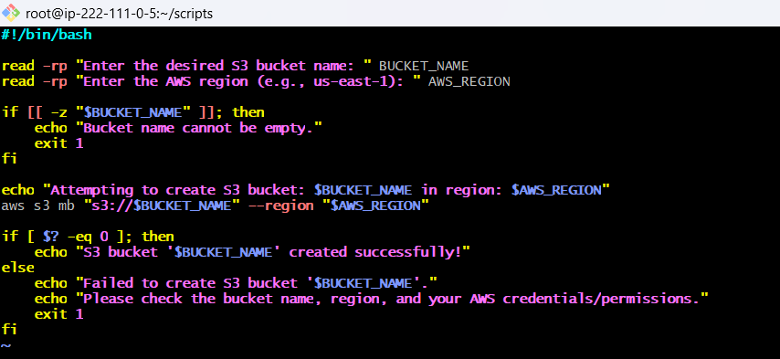
Step 3: Run the script.
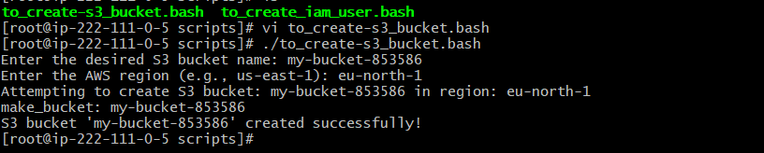
Step 4: check for created bucket using aws s3 ls and in S3 in AWS console.
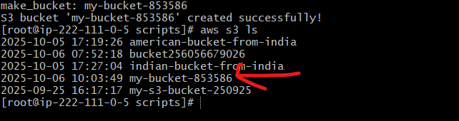

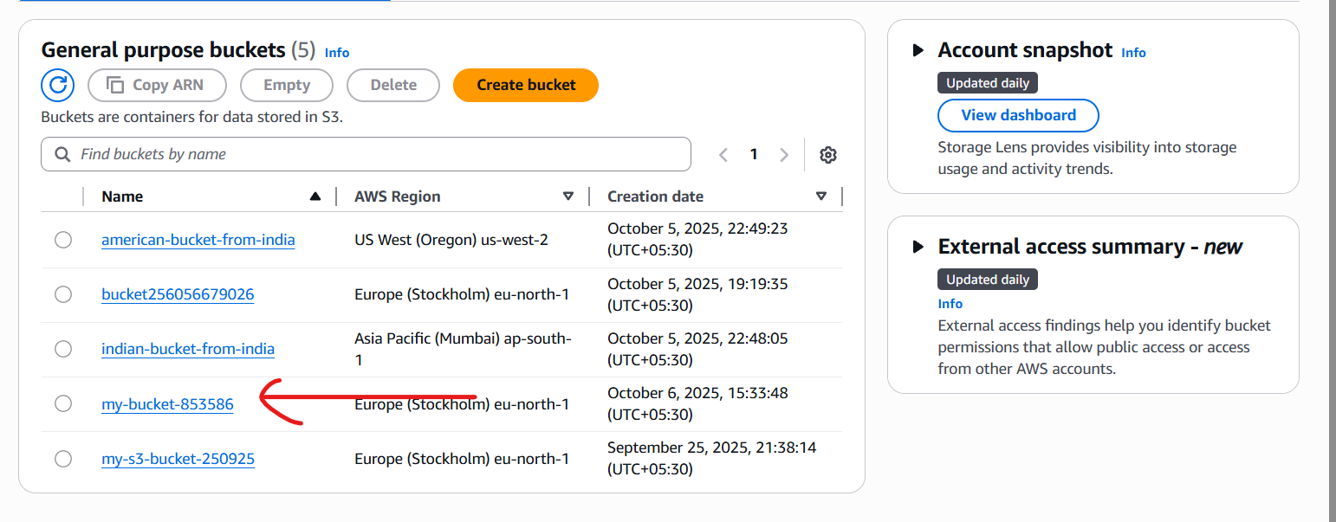

- Upload a 1 GB file to S3 using the CLI.
Step 1: Configure aws and check for s3 bucket in local machine.
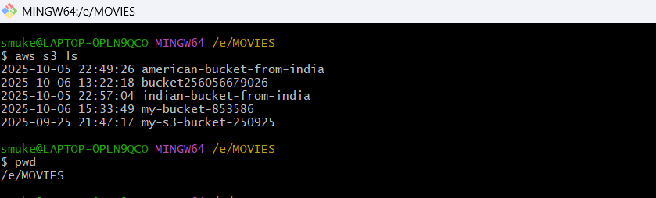
Step 2: Use aws s3 cp path s3://bucket_name/object_name to upload file.
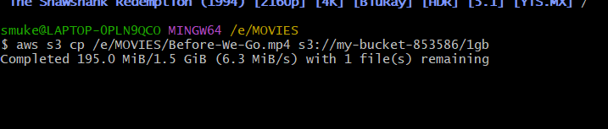
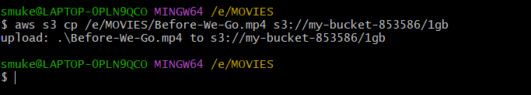

Step 4: Check for the file in AWS console.
